90

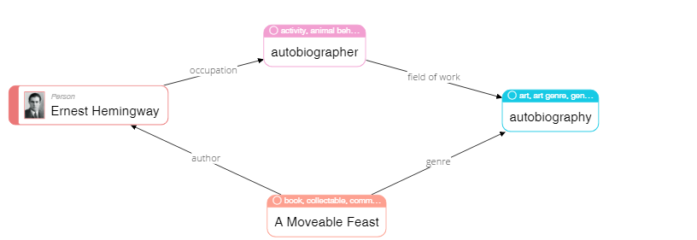

|  |
| --- |
| **Please describe shortly what you see on this diagram? Pay attention only to that information that is understandable or has sense for you.** |
| I see that Ernest is a person who wrote A Moveable Feast and it is autobiography. |

68

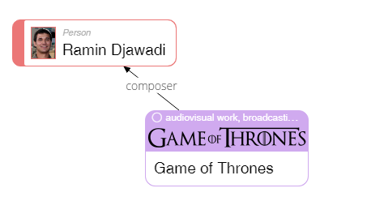

|  |
| --- |
| **Please describe shortly what you see on this diagram? Pay attention only to that information that is understandable or has sense for you.** |
| I can see that Ramin Djawadi wrote music for the “Game of Thrones” |

23

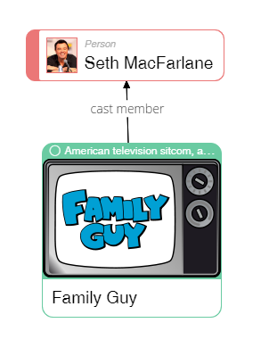

|  |
| --- |
| **Please describe shortly what you see on this diagram? Pay attention only to that information that is understandable or has sense for you.** |
| I see that Seth MacFarlane participated in casting on the role in Family Guy. |

50

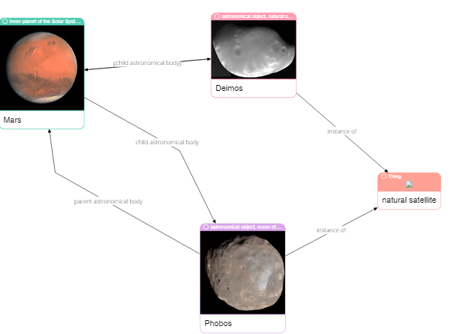

|  |
| --- |
| **Please describe shortly what you see on this diagram? Pay attention only to that information that is understandable or has sense for you.** |
| I see three space bodies and some relations between this bodies. |

62

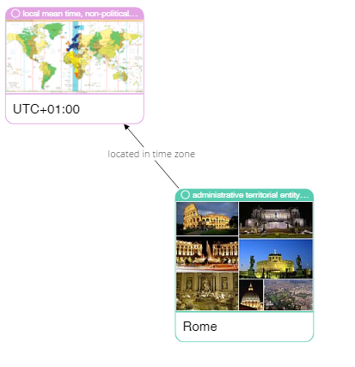

|  |
| --- |
| **Please describe shortly what you see on this diagram? Pay attention only to that information that is understandable or has sense for you.** |
| I see that Rome is located at UCT+01:00 time zone. |

75

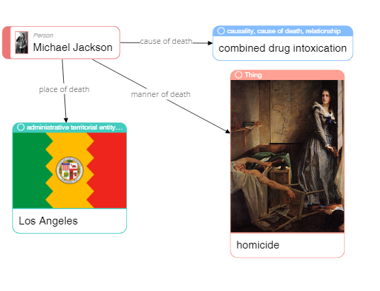

|  |
| --- |
| **Please describe shortly what you see on this diagram? Pay attention only to that information that is understandable or has sense for you.** |
| Michael Jackson was dead in the LA by a drug intoxication reason. |

79

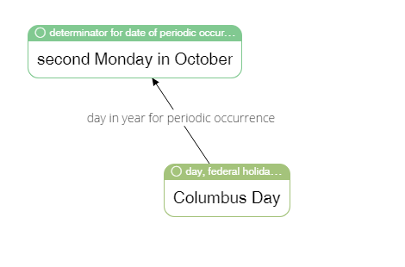

|  |
| --- |
| **Please describe shortly what you see on this diagram? Pay attention only to that information that is understandable or has sense for you.** |
| Columbus day is the second Monday in October. |

65



|  |
| --- |
| **Please describe shortly what you see on this diagram? Pay attention only to that information that is understandable or has sense for you.** |
| Lego was invented by Ole Kirk who is carpenter, joiner and entrepreneur |

4

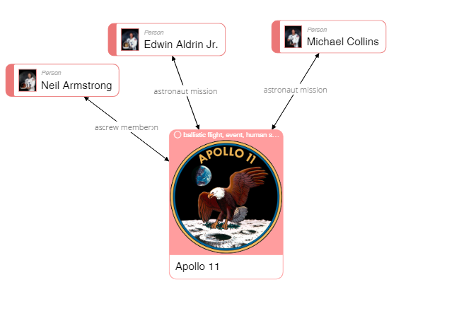

|  |
| --- |
| **Please describe shortly what you see on this diagram? Pay attention only to that information that is understandable or has sense for you.** |
| Neil Armstrong, Edwin Aldrin Jr. and Michael Collins are members Apollo 11’s crew.  And the crew of Apollo 11 consisted of Neil Armstrong, Edwin Aldrin Jr. and Michael Collins. |

40

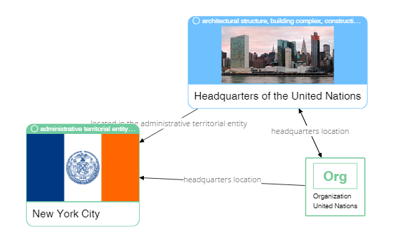

|  |
| --- |
| **Please describe shortly what you see on this diagram? Pay attention only to that information that is understandable or has sense for you.** |
| UN headquarter is located in New York City, on the administrative territorial entity. |

37



|  |
| --- |
| **Please describe shortly what you see on this diagram? Pay attention only to that information that is understandable or has sense for you.** |
| F.C. Porto is the football club of Porto and it’s headquarter is Estadio do Dragao. |